

Bell Lets Talk Day - January 22, 2025

PHC recognizes the importance of mental health today and every day for all Canadians and members of our community, that’s why we are proud to participate in **Bell Let’s Talk Day** on January 22, 2025. **Bell Let’s Talk Day** is a day in which we recognize the importance of mental health awareness and the need to take meaningful steps to eliminate the stigma.

This year, the campaign highlights the progress that has been made and discusses what still needs to be done to support those with mental health challenges including Canada’s Youth who are facing a growing mental health crisis.

Here are some ways you can get involved:

* **Start the Conversation:** Take a moment to check in with your colleagues, friends, or loved ones. Sometimes, a simple “How are you really doing?” can make all the difference.
* **Raise Awareness:** For every social media interaction (such as using the hashtag **#BellLetsTalk**) on the day, Bell donates a portion of their proceeds to mental health programs across Canada.
* **Send a Text:** Text **YOUTH** to **45678** to donate $5, Bell will match all $5 donations up to a total of $1 million.

PHC recognizes the importance of prioritizing mental wellbeing both in our personal life and in the workplace. We support each other in making our mental health a top priority and encourage each other to raise a hand if we are struggling and need help.

We encourage you to participate and join in the movement for CHANGE.

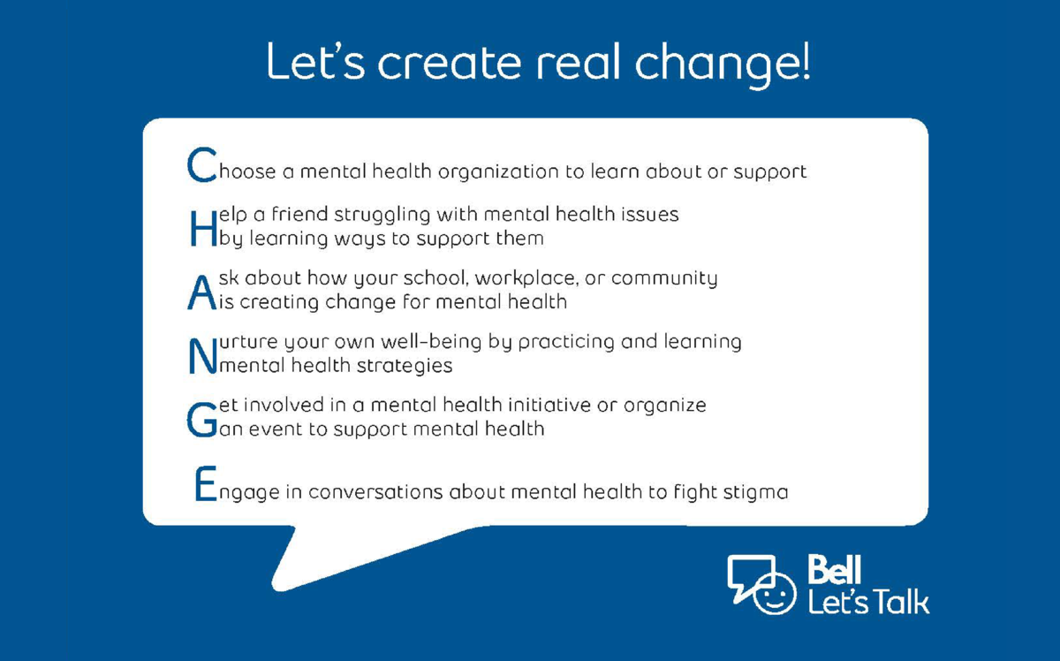

Resources are available at <https://letstalk.bell.ca/>